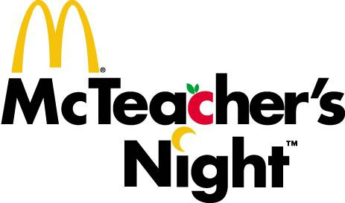
Tuesday, October 17, 2017
5 – 8 pm
Sponsored by
McDonald’s of South Riding
Honoring
Hutchison Farm Elementary PTA
Dine-in or Drive-thru
Come for food and fun or just order and go.
All the work is done for you.
No need to save receipts for recording.

